Final Paper
Criminal Law 203

Part I

You are a law clerk and a judge hands you a thick case file of information describing an event comprised of multiple crimes and parties. At least one crime is a property crime and at least one crime is a public order crime. (There are no crimes of homicide or crimes against the person.) There are at least three different types of parties to the crimes.

Write a fact pattern to the judge describing the crimes and the parties, using enough detail for the judge to make legal decisions on who is guilty for which crimes and why. The fact pattern should be a formal narrative (story) for the judge that describes the events and details in a chronological order.

Length: approximately 3- pages, double-spaced
Fact Pattern example:
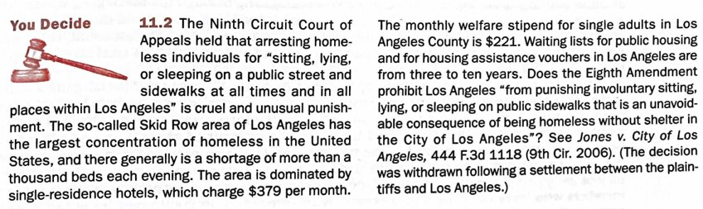
Part II

You are now either a prosecutor or defense attorney. Using the fact pattern that you wrote in Part I, argue the legal guilt or innocence of the parties.

If you choose to be the prosecutor, argue that each of the parties in your fact pattern are guilty of crimes and why. Be sure to tell the reader what the legal elements of the crime are and why the evidence supports the legal elements.

If you choose to be the defense attorney, argue that each of the parties in your fact pattern are guilty of crimes and why. Be sure to tell the reader what the legal elements of the crime are and why the evidence supports the legal elements. Be sure to tell the reader what the legal elements of the crime are and why the evidence does not support the legal elements (making each party not guilty).

Write a memo, in essay format, explaining to your argument. Be sure to support your legal reasoning with specific information from the fact pattern in Part I. At the end of the essay, discuss a potential policy outcome from your legal analysis that may have a larger impact on some groups of people in society.

Length: approximately 3- pages, double-spaced

Elements of a Crime - https://youtu.be/_fi4RoTW2io
Actus Reas — The Act - https://youtu.be/l9GSjonISsQ
Mens Rea — The Mindset (Intention) - https://youtu.be/cI7g6oVQ1Qo
Is it a crime? - https://youtu.be/CUjJRG0wE_E
Rap Lyrics Conviction - https://www.pbs.org/newshour/nation/nj-supreme-court-strikes-conviction-based-rap-lyrics

Defenses Overview - https://youtu.be/58ulSSoFWjo
Lack of Capacity - https://youtu.be/w39A7yu7Ulw
Justification and Excuse Defenses - https://youtu.be/n6dU9ZSJX3U
Dudly v. Stephens - https://www.youtube.com/watch?v=A03p_egwaSg
Justification of Force Defenses - https://youtu.be/M9lPuXAggmA

Inchoate Crimes Overview - https://youtu.be/FO1EtXFHxk8
Attempt - https://youtu.be/w-2d6Mwyaa4
Solicitation - https://youtu.be/O6xMKk3oITg
Conspiracy - https://youtu.be/2SwprbWtZWY
Abandonment - https://youtu.be/qr1cJtOEcPo
Impossibility - https://youtu.be/K0bXpT1RR3c

